**Mr. Visca’s: Calculus (Chpt 2.2)**

**Chpt 2 – Day 5 End Behavior of Functions**

**End Behavior Model:**

* a ____________________ model for f if and only if :
* a ____________________ model for f if and only if :

Let f(x) = 3x4 - 2x3 + 3x2 - 5x + 6, and let g(x) = 3x4; show that while f and g are quite different for numerically small values of x, they are virtually identical for |x| large.

Let f(x) = x + e-x. Show that g(x) = x is a right end behavior model for f while h(x) = e-x is a left end behavior model for f.

**End Behavior Model of a Functions**

Simple...it's the term with the __________________________

If it's a fraction, take ___________________ of the ______________ and _____________ then simplify.

What is the end behavior model of f(x) = 4x3 - 6x2 + 15x - 9 ?

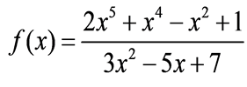

Find the end behavior model for:

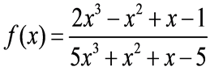

Find the end behavior model for:

*HW: section 2.2*

*#s 35-47 odds only & 54*